Thank You For Purchasing Our Laser Tape Measure

Please read the safety terms and instructions carefully before using this product for the first time.
1. SAFETY TERMS:
Please read all the terms and instructions in this manual carefully before using this product,failure to follow these safety terms and guidelines may cause dangerous laser radiation injury,electric shock or personal injury.
Do not attempt to change the performance of the laser in any way which may
cause laser exposure and causing danger.only turn on the laser when using this instrument.
Do not look at the laser straight.Please keep your Instrument well to avoid irrelevant personnel use it.
Do not irradiate others with laser intentionally or in the dark.
Do not irradiate laser on objects with high reflective surfaces.
Do not put the instrument where children can touch it.
Do not repair this instrument without permission.please contact local dealer if the instrument is damaged.
Electromagnetic radiation may interfere with other equipment and devices
(Medical devices such as pacemakers or hearing AIDS etc.)
Do not use this instrument in inflammable and explosive environment.
Do not use this instrument near medical equipment.
Do not use this instrument on airplanes.
Please dispose the abandoned instrument according to your local regulations&law.


2. Button and Display
Button: Turn on/Laser on/Measure/Datum mark switch/Turn off/Setting
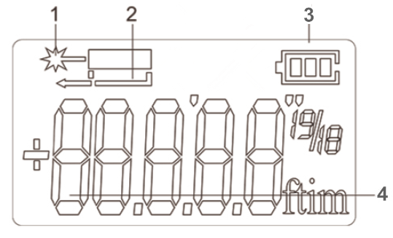
Display:
- Laser on indicator
2. Datum mark indicator
3. Battery power indicator
4. Main display area

3. Start
Battery and Charging:

This laser tape measure contains rechargeable lithium battery, not need to replace extra battery. If the instrument can’t be turn on, maybe the battery power is too low. when the battery is too low, the icon will indicating the battery is too low will appear on the screen, this time please charge the instrument in time with USB cable. it can be fully charged in 2 hours.

Important Note: The screen will not light up during charging and will not Prompt it’s charging, that is normal, this is not issue, the instrument can be fully charged in 2 hours.

4. Operation
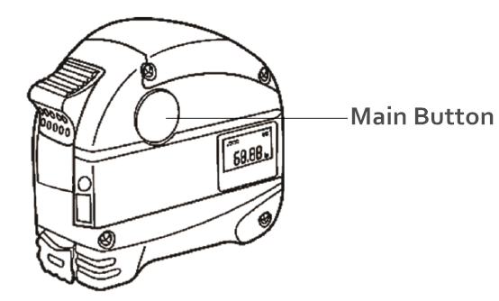
· Turn on: press the main button for about 2 second to turn on the instrument when it is off,the backlight will be automatically switched off after 15 seconds if the instrument without any operation.

· laser on/Measure: in the state of turning on,short press the main button one time the laser beam will be light on,then press second time it will measure and the laser will automatically off after finished measuring.

· Datum mark switch: in the state of turning on,long press the main button for about 3 seconds to switch the Datum mark,when restart the instrument,it restore the default Datum mark.

· Turn off: long press the main button for 5 seconds in the state of turning on to turn off the instrument,and the instrument will automatically turn off after 45 seconds if without any operation.

· Setting: long press the main button for about 5 seconds to enter the setting in the turn off state,in the setting state,long press the main button for about 1 second to switch settings.the measuring value can be corrected within the range of +/-7mm,short press the main button can be adjust the values.

5. Prompt code and solution
Following messages may prompt on the instrument when using the instrument:

Code | Cause | Solution
B.L | Battery is too low | Charge the battery
T.L | Temperature is too low | Warming temperature of the instrument
T.H | Temperature is too high | Cooling down temperature of the instrument

6. Technical Parameters

Measuring Accuracy | ±3mm*
Unit | m/in/ft
Measurement Range(No reflection plate) | 0.03-30m**
Measuring Time | 0.3-4s
Laser Type | 620~670nm,<1mw
laser beam auto off time | 15s
Instrument auto off time | 45s
Display lighting | White LED
Datum mark switch | √
Battery power status | √
Battery type and life | Rechargeable Li-ion Battery/Fifty thousand times
Net Weight | 300g/0.29 LB
Operating temperature range | 0 C°～40 C°
Storage temperature range | -20 C°～60 C°

* under the bad measuring condition (such as the environmental light is too strong,the diffuse reflectance of measured points is too large or too small, and excessive temperature differentials etc.),the measurement error can reach to ±0.25mm/m.
** Please use the aiming board when there is strong sunlight or poor reflection of the target!

7. Maintain
·Do not immerse the instrument in water,wipe the surface dust with a wet soft cloth, and do not use erosion lotion.
·Wipe the surfaces of optical components (including the laser exit lens and signal receiving lens) by wiping the glasses and camera lens.

